End-to-End AI Medical Imaging → PACS Process

🧠 Big Picture (One-Line)
Medical Image → AI Analysis → Structured Output → PACS Integration
Your system acts as a clinical decision-support AI engine, not a diagnostic system.
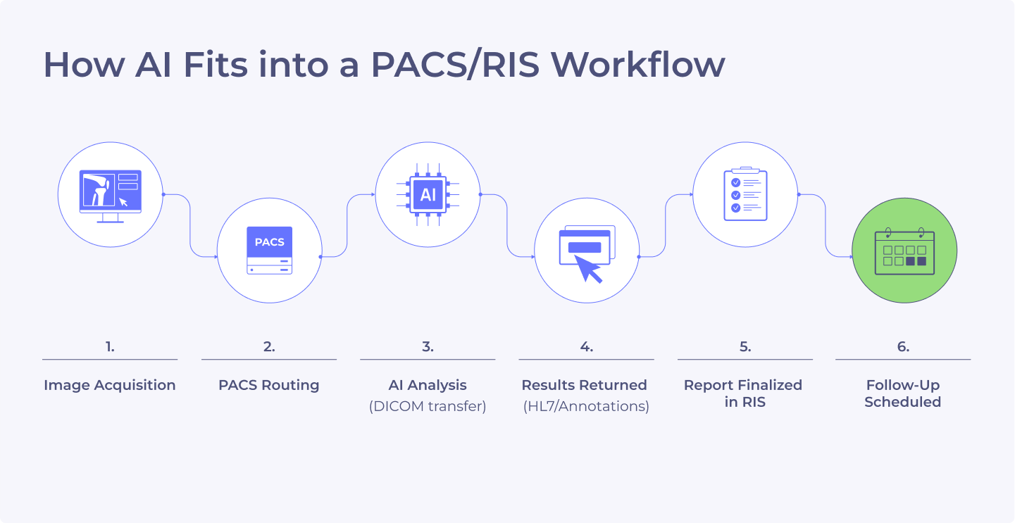
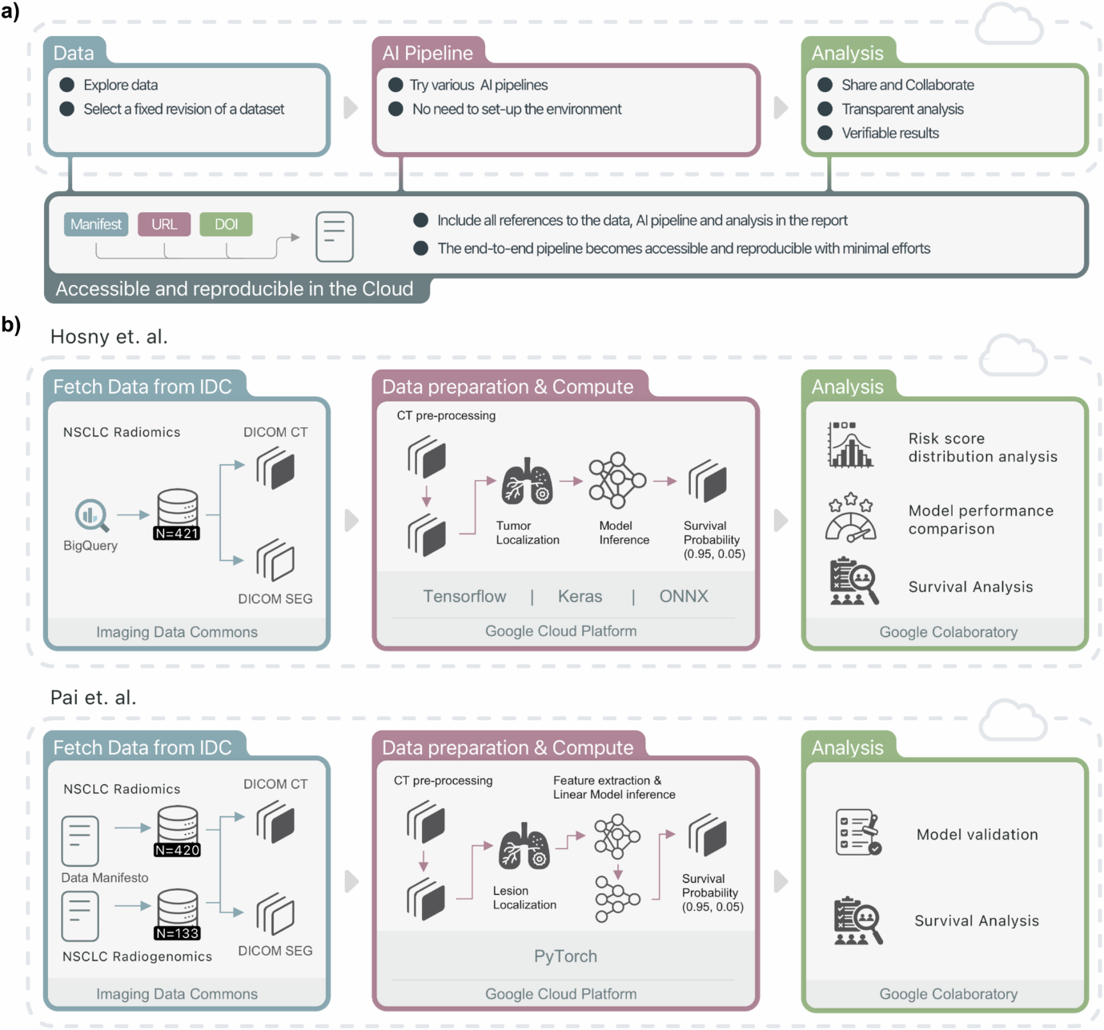
STEP 1️⃣ Image Comes from Hospital / User
What enters the system
- Modalities
  - X-Ray
  - CT
  - MRI
- Formats
  - DICOM (main hospital format)
  - JPEG / PNG / TIFF (for X-ray uploads)
Where it comes from
- PACS export
- Radiology workstation
- Doctor upload
- Research dataset
At this stage, the image is raw and untouched.

STEP 2️⃣ Modality Detection & Routing

The system identifies:
- Is it X-Ray, CT, or MRI?
- Is it DICOM or image file?
Why this matters
Each modality:
- Uses different physics
- Needs different preprocessing
- Uses different AI models
So the system routes the image to the correct pipeline.
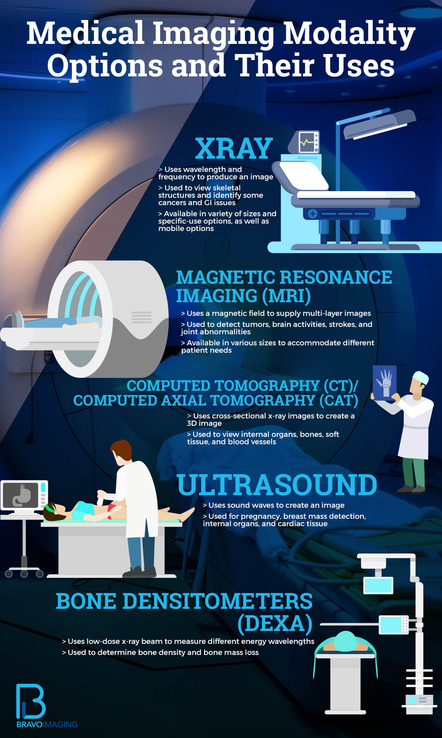

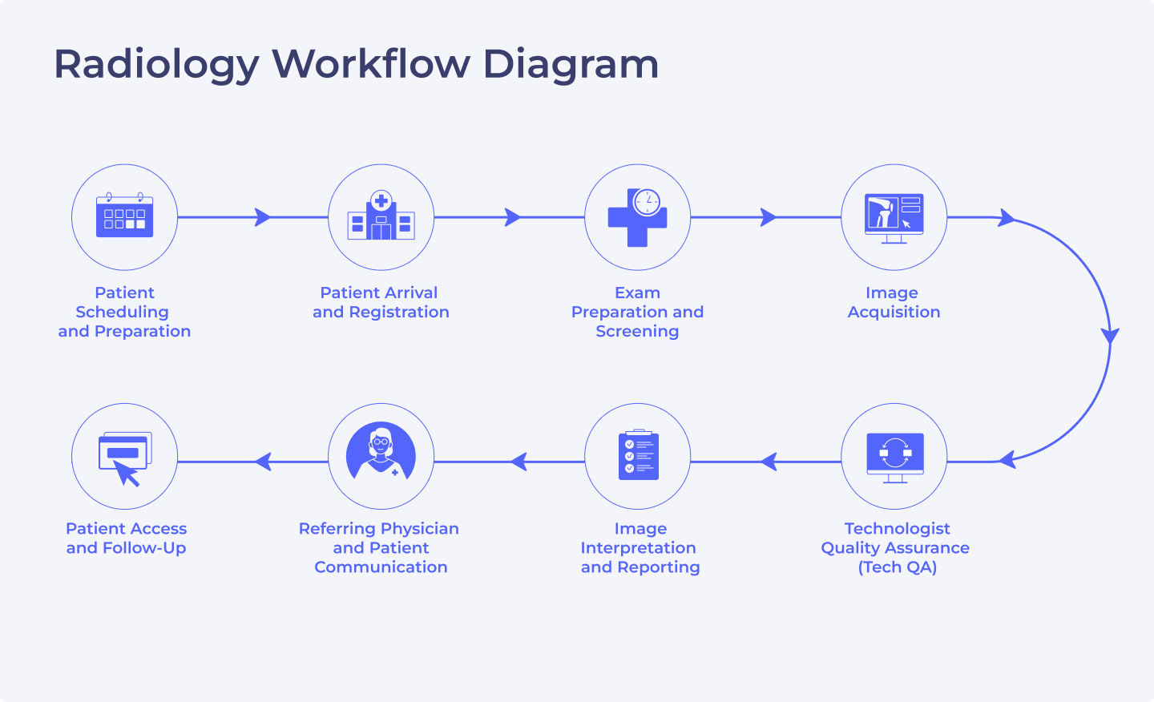
STEP 3️⃣ Image Loading & Standardization
If X-Ray (JPEG/PNG)
- Converted to grayscale
- Normalized
- Resized to model input size
If CT / MRI (DICOM)
- Pixel data extracted
- Intensity normalized
- Converted to 3D volume (slices stacked)
At the end of this step:
All inputs look numerically consistent to AI models.

STEP 4️⃣ Preprocessing (Model-Friendly)

This step:
- Removes noise
- Normalizes intensity ranges
- Ensures consistent resolution
Important rule
🚫 No enhancement that changes medical meaning
✔ Only mathematical normalization
This keeps the system clinically safe.

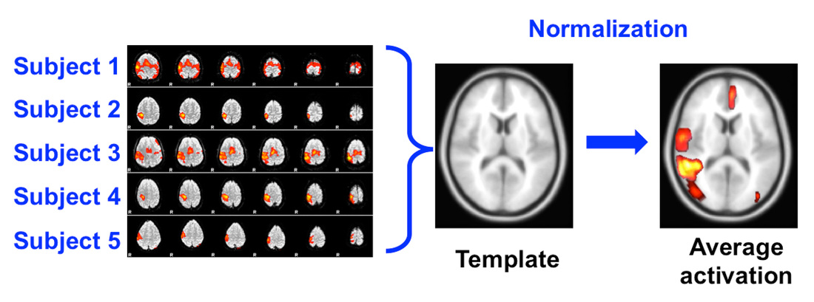

STEP 5️⃣ AI Analysis (Analysis-Only)

Different AI models run in parallel, depending on modality.
X-Ray
- Abnormality detection
- Pattern confidence
- Heatmap generation
CT
- Lung lesion detection
- Organ segmentation
- Volume & size measurement
MRI
- Soft-tissue lesion segmentation
- Tumor volume calculation
⚠️ No diagnosis is made
⚠️ No recommendation is generated
Only measurable, observable facts.

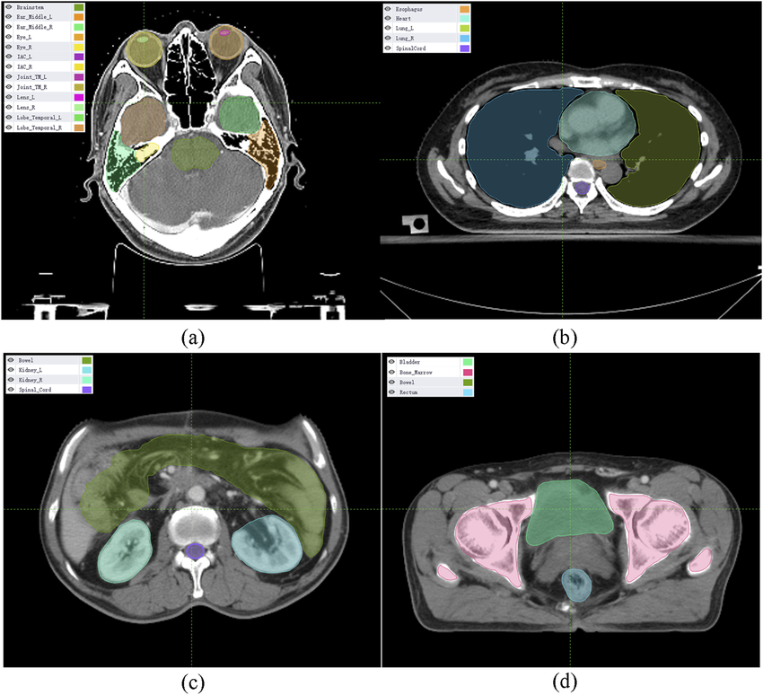

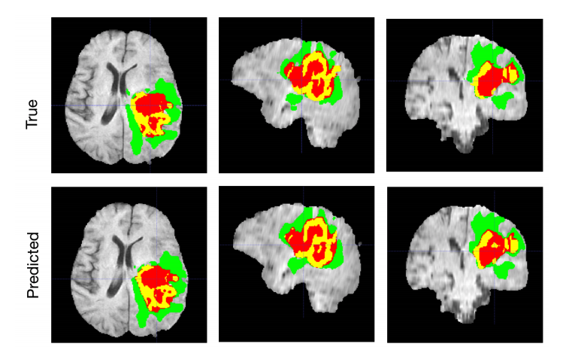
STEP 6️⃣ Raw AI Outputs (Internal)
At this stage, AI produces things like:
- Masks (binary images)
- Heatmaps
- Numeric values
- Confidence scores
These are not yet hospital-usable.

STEP 7️⃣ DICOM Metadata Extraction

From the DICOM file, the system extracts:
- Study UID
- Series UID
- Instance UID
- Modality
- Body part
Why this is critical
This is how PACS knows:
“These results belong to THIS exact scan”
Without this, hospitals will reject the AI output.

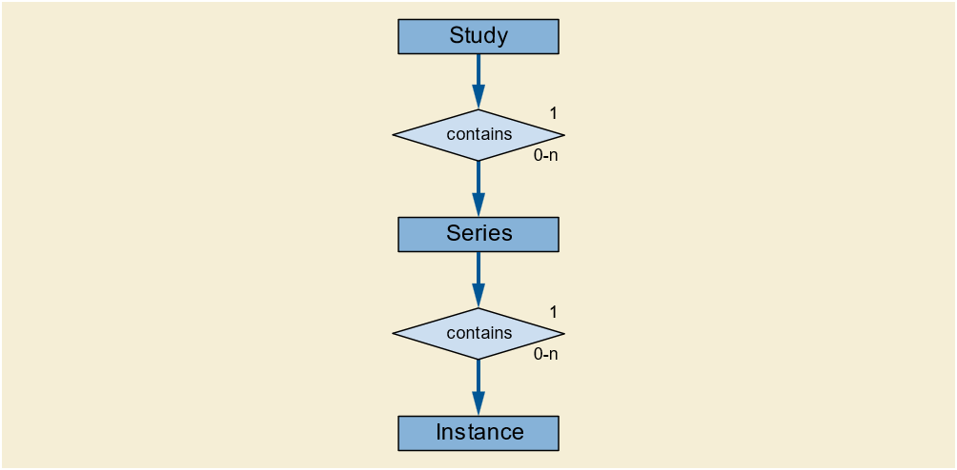
STEP 8️⃣ PACS-Ready JSON Creation

All results are wrapped into a PACS-ready JSON that includes:
- Study & patient linkage
- Structured analysis results
- Confidence values
- AI system metadata
- Compliance declarations
- Audit timestamps
What it avoids
❌ Diagnosis
❌ Treatment
❌ Recommendations
This makes it regulation-friendly.
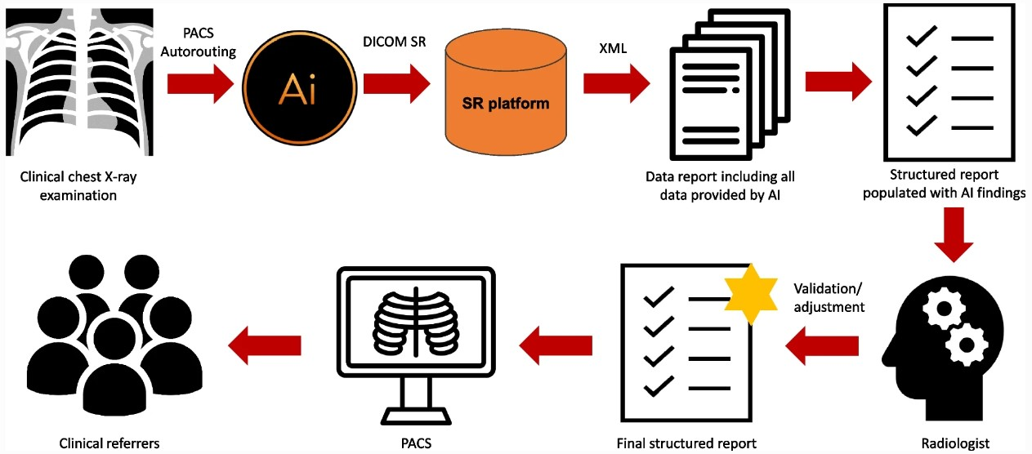
STEP 9️⃣ Output Storage & Optional Conversion
At this point, the output can:
- Be stored in PACS as metadata
- Be attached to the study
- Be converted to DICOM SR (optional)
- Be displayed as overlays in PACS viewers
Hospitals usually start with JSON → later move to DICOM SR.

STEP 🔟 Radiologist / Clinician View

Inside PACS, the radiologist sees:
- Original scan (unchanged)
- AI heatmaps (toggle on/off)
- Measurements & volumes
- Confidence indicators
The doctor stays in full control.

